Communicating with Data in the Tidyverse

DataCamp

March 2018

The following plot shows the relationship between the number of cylinders and miles per gallon in the mtcars dataset.

boxplot(mtcars$mpg ~ mtcars$cyl)

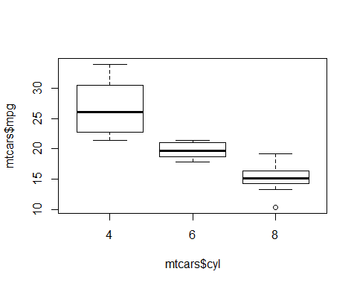

As one can see, the more cylinders, the less miles per gallons.